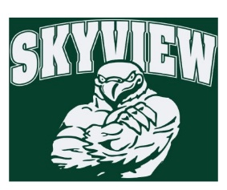
12.3.17 Edition
HAWK HAPPENINGS

Love Art! –Good news! A new after school program is being offered for Skyview students starting this January. Be sure to sign up!

To register for classes, please go to www.methacton.org/comed. Questions? Please email Kathy Kifer at kkifer@methacton.org. Thank you.

WINTER 2018 COMMUNITY ED BROCHURE.pdf

Directory –Student directories are available in limited supply. Orders are on a first-come first-serve basis. If interested, send $5 into the office noting “School Directory” with your student’s name and homeroom. Orders sent in the previous week will be sent home this week!
Lost and Found – Please remind your student to check out the lost and found in the main lobby. All unclaimed items will be donated at the holidays.
Spirit Wear –First Friday is December 8. Be sure to wear your Spirit Wear! Skyview apparel is available for purchase at yourstartinglineup.com. All items can be customized with a school logo, your name, and more. Spirit wear makes great holiday gifts while showing your school spirit! All sales benefit your child's school. All items are custom and take 2-3 weeks for delivery! www.yourstartinglineup.com.
Yankee Candle – Our on-line store will be open until January 2018! Yankee makes the best gifts and better yet, Skyview earns 40% of sales. There are two ways to obtain sales: 1.Online Sales ‐ set up a seller’s login at www.yankeecandlefundraising.com 2.The New Mobile App – download Yankee Fundraising at Google Play or Apple App Store
Delivery: For those unable to pick up their orders last week, boxes are in the front office (alphabetized), this week only. After this week, orders will be stored in a secure area and need an appointment.
~Skyview Group #: 999971230 ~ www.yankeecandlefundraising.com Any questions please contact Courtney Kusy at courtcopp621@gmail.com
Skyview Bowling Club – Only 3 weeks left! 12/5/, 12/12, and 12/19. Report to recess doors at 1st bell dismissal.

